 | IQVIATM Work Instruction  Global Regulatory Affairs – IND Submissions
Document Number and Revision:
CS_WI_RA0297 Revision 1
Document Owner:  Anja De Pauw | Author(s):  Maggie Rahman

PURPOSE
To describe the regulatory activities associated with United States (US) Investigational New Drug (IND) submissions to the US Food and Drug Administration (FDA).

SCOPE

  - This work instruction (WI) applies to all GRA staff involved in the preparation, review and approval of INDs.

  - One or more of the steps shown in section 6.0 may be in scope for a specific sponsor

ROLES AND RESPONSIBILITIES
The following roles perform tasks described within this WI:

Role | Sections
Regulatory Project Manager (RPM)/GRA Project Lead | 6.1, 6.2, 6.3, 6.4, 6.5, 6.6, 6.7
Regulatory Team Member (RTM) | 6.1, 6.2, 6.3, 6.4, 6.5. 6.7
Regulatory Publisher (RP)/electronic Common Technical Document Lead (eCTD Lead) | 6.1, 6.7
Subject Matter Expert (SME) for clinical, non-clinical, pharmacokinetics (PK) or Chemistry, Manufacturing and Controls (CMC) | 6.2, 6.3

DEFINITIONS
IND: Investigational New Drug
- Commercial or research IND
- Does not include Emergency Use IND or treatment IND

IND Protocol Amendments include
- New protocol; change in protocol
- New or updated Principal Investigator

Pre-IND:
- Type B pre-IND meeting

MATERIAL AND EQUIPMENT
Not Applicable

Page 1 of 14
Copyright © 2022. IQVIA. All rights reserved. The contents of this document are confidential and proprietary to IQVIA Holdings Inc. and its subsidiaries. Unauthorized use, disclosure or reproduction is strictly prohibited.

PROCEDURE

  - Step 1: Award & Kick-Off meeting

No: | Who: | Step: | When:
6.1.1 | RPM | - Receives the signed Work Order from GBO (Global Business Operations) contracts  - Contacts the Project Finance Manager to set up the project in the IQVIA finance system | At project award
6.1.2 | RPM | - Initiates Project Kick-Off  - Requests resource from other functions, as required (e.g. Medical Writing (MW), Pharmacokinetics (PK),  Strategic Drug Development (SDD), or therapeutic Center of Excellence (COE)) | After project has been awarded
6.1.3 | RPM | - Finalizes the core team | After resource has been requested
6.1.4 | RPM | - Prepares internal alignment for Kick-Off (KO) meeting  - Requests Publishing team to prepare SharePoint, sFTP site and Project Guidelines | After core team is finalized
6.1.5 | RP | - Creates SharePoint, sFTP site and Project Guidelines (Refer 6.1.1 to 6.1.4 of CS_WI_RA0292) | Request received from RPM
6.1.6 | RPM | - Conducts Kick-Off (KO) meeting with sponsor | Project systems have been set up
6.1.7 | RPM | - Sends out meeting minutes  - Receives material from Sponsor via sFTP and SharePoint | After KO meeting
6.1.8 | RPM | - Confirms to Sponsor that material has been received | Receipt of material from Sponsor

  - Step 2a: Gap Analysis Report

No: | Who: | Step: | When:
6.2.1 | RPM | - Initiates review of material by SMEs:  - Regulatory  - CMC  - PK  - Clinical  - Non-clinical  - Requests SME assistance from non-GRA staff when required | After the KO meeting

No: | Who: | Step: | When:
6.2.2 | SME | - Conducts regulatory, PK, clinical, non-clinical and CMC review of material and records findings in the Gap Analysis Report (typically in PowerPoint)  - Provides results to RPM | Request received from RPM
6.2.3 | RPM | - Receives and reviews input from SME  - Receives and reviews input from non-GRA team members  - Sets up an internal meeting to discuss preliminary Gap findings  - Requests additional information from the Sponsor, if required | PowerPoint slides received
6.2.4 | RTM | - Prepares draft Gap Analysis Report  - Sends to RPM for review | After internal gap analysis meeting
6.2.5 | RPM | - QC (Quality Control) reviews draft Gap Analysis Report  - Sets up internal meeting to discuss Report, if required  - Sends to Sponsor to review | Receipt of draft Gap Analysis Report
6.2.6 | RTM | - Addresses Sponsor’s comments in revised Gap Analysis Report | Sponsor’s review received
6.2.7 | RPM | - QC reviews revised Report  - Sends to Sponsor for final review  - Receive confirmation from Sponsor that Report is final | Receipt of revised Gap Analysis Report
6.2.8 | RPM | - Defines next steps with the GRA project team  - Communicates outcome to non- GRA team | Confirmation of final Gap Analysis Report

  - Step 2b: IND Readiness Assessment

No: | Who: | Step: | When:
6.3.1 | RPM | - Initiates review of material by SMEs:  - Regulatory  - CMC  - PK  - Clinical  - Non-clinical  - Requests SME assistance from non-GRA staff when required | After Data Lock of the clinical trial data and the KO meeting
6.3.2 | SME | - Conducts regulatory, PK, clinical, non-clinical and CMC review of material and records findings in the IND Readiness Report (typically in PowerPoint)  - Provides results to RPM | Request received from RPM

No: | Who: | Step: | When:
6.3.3 | RPM | - Receives and reviews input from SME  - Receives and reviews input from non-GRA team members  - Sets up an internal meeting to discuss preliminary IND Readiness findings  - Requests additional information from the Sponsor, if required | PowerPoint slides received
6.3.4 | RTM | - Prepares draft IND Readiness Report  - Sends to RPM for review | After internal IND Readiness meeting
6.3.5 | RPM | - QC reviews IND Readiness Report  - Sets up internal meeting to discuss Report, if required  - Sends to Sponsor to review | Receipt of Draft IND Readiness Report
6.3.6 | RTM | - Addresses Sponsor’s comments in revised IND Readiness Report | Sponsor’s review received
6.3.7 | RPM | - QC reviews revised Report  - Sends to Sponsor for final review  - Receive confirmation from Sponsor that Report is final | Receipt of revised IND Readiness Report
6.3.8 | RPM | - Defines next steps with the GRA project team  - Communicates outcome to non-GRA team | Confirmation of final IND Readiness Report

  - Step 3a: Pre-IND Meeting Request

No: | Who: | Step: | When:
6.4.1 | RPM | - Conducts meeting with Sponsor to discuss plan  - Requests functional team to support meeting request  - Receives required information/support from Sponsor  - Prepares pre-IND meeting request to FDA | Sponsor requires pre-IND meeting
6.4.2 | RPM | - Requests Sponsor to review meeting request | Pre-IND meeting requested prepared
6.4.3 | RPM | - Addresses Sponsor comments and revises request  - Sends the pre-IND request to the RP | Receipt of Sponsor’s comments
6.4.4 | RP | - Publishes meeting request in eCTD  - Submits eCTD meeting request to FDA (Refer CS_WI_RA0280) | Receipt of meeting request, at least 60 days prior to FDA meeting date
6.4.5 | RPM | - Receives FDA notification of Pre-IND meeting date | Within 21 days after submission of meeting request

  - Step 3b: Preparation and Submission of Meeting Information Package (MIP)/Briefing document

No: | Who: | Step: | When:
6.5.1 | RPM | - Plans preparation of:  - Investigational Brochure (IB) for MIP (if required)  - Clinical Study Protocol Synopsis  - Pre-IND MIP | Receipt of FDA notification
6.5.2 | RTM | - Requests documents from other team members and sponsor for MIP (e.g. IB, Product Specifications/Stability Plan, Clinical Protocol/Synopsis or other non-clinical data)  - Prepares draft MIP and sends to RPM for review | Plan in place
6.5.3 | RPM | - QC reviews draft MIP  - Sends to Sponsor for review  - Receives comments from Sponsor | Receipt of draft MIP
6.5.4 | RTM | - Finalizes MIP  - Sends to the RP | Receipt of RPM and Sponsor comments
6.5.5 | RP | - Publishes MIP in eCTD  - Submits MIP to FDA (Refer CS_WI_RA0280) | At least 30 days before meeting date
6.5.6 | RPM | - Receives preliminary FDA comments | At least 1-2 days prior to scheduled meeting
6.5.7 | RPM | - If applicable, addresses FDA comments with team | Receipt of FDA comments

  - Step 3c: Pre-IND meeting rehearsal and meeting

No: | Who: | Step: | When:
6.6.1 | RPM | - Agrees with Sponsor who should lead the Pre-IND meeting | Prior to Pre-IND meeting
6.6.2 | RPM | - Leads Pre-IND meeting rehearsal with project team members and Sponsor, if requested by Sponsor, to discuss preliminary responses received from FDA | After agreement with Sponsor on who leads the meeting
6.6.3 | RPM | - Leads Pre-IND meeting with FDA | At Pre-IND meeting with FDA
6.6.4 | RPM | - Leads debrief meeting with Sponsor and project team  - Receives FDA final minutes  - Communicates FDA final minutes to Sponsor and project team | After Pre-IND meeting
6.6.5 | RPM | - Provides FDA final minutes to Medical Writing to generate full clinical study protocol | Receipt of FDA final minutes

  - Step 4: IND submission

No: | Who: | Step: | When:
6.7.1 | RPM | - Agrees timing of IND submission with Sponsor | After Pre-IND meeting with FDA
6.7.2 | RTM | - Coordinates preparation of Module 1:  - Requests Sponsor to provide Letter of Authorization and Investigational Product Label  - FDA Pre-IND meeting minutes  - Requests Site Activation to provide Transfer of Regulatory Obligations (TOROs)  - Requests US Agent to create Cover letter form; 1571 form; 3674, General Investigational Plan, and Environmental Analysis (or waiver)  - Requests Medical Writing to provide IB (if requested by Sponsor) | At agreed timing
6.7.3 | RPM | - QC reviews Module 1  - Sends to Sponsor for review | Module 1 prepared
6.7.4 | RTM | - Coordinates preparation of Module 2:  - Prepares Module 2.2, 2.4 and 2.6 | At agreed timing
6.7.5 | RPM | - QC reviews Module 2  - Sends to Sponsor for review | Module 2 prepared
6.7.6 | RTM | - Coordinates preparation of Module 3:  - Prepares Module 3 | At agreed timing
6.7.7 | RPM | - QC reviews Module 3  - Sends to Sponsor for review | Module 3 prepared
6.7.8 | RTM | - Coordinates preparation of Module 4:  - Requests RTM to provide non-clinical input as requested by Sponsor  - Requests literature searches, if requested by Sponsor  - Sends Module 4 Literature to Sponsor | At agreed timing
6.7.9 | RPM | - Confirms with Sponsor that Module 4 is ready for Publishing | Module 4 data provided to Sponsor
6.7.10 | RTM | - Coordinates preparation of Module 5:  - Requests Sponsor and/or other team members to provide Clinical Study Reports, Protocol, Investigator CV and 1572 | At agreed timing
6.7.11 | RPM | - QC reviews Module 5  - Sends to Sponsor for review | Module 5 prepared
6.7.12 | RPM | - Provides CTD Modules to RP via the Publishing drive | CTD Modules are ready to be published

No: | Who: | Step: | When:
6.7.13 | RP | - Develops Submission tracker  - Pre-publishes documents and make ready for QC  - Publishes documents and performs validation step  - Send final package to RPM for review (Refer CS_WI_RA0292) | Receipt of CTD Modules
6.7.14 | RPM/RTM | - Reviews package | Receipt of eCTD package
6.7.15 | RPM | - Sends to Sponsor for review  - Receive confirmation from Sponsor to submit | Receipt of review
6.7.16 | RP | - Submit the files and uploads to the ESG (Electronic Submissions Gateway) (Refer CS_WI_RA0292) | Confirmation from Sponsor to submit

- SUPPORTING DOCUMENTATION

DOCUMENT NUMBER | TITLE
ESOP References
7.1 CS_WI_RA0292 | Publishing - Producing Clinical and Submission Publishing Deliverables
7.2 CS_WI_RA0280 | Global Regulatory Affairs - US Maintenance Submissions
- SUPERSEDES

DOCUMENT NUMBER | TITLE | REVISION NUMBER
Not Applicable | Not Applicable | Not Applicable
- MODIFICATION FROM PREVIOUS REVISION

CHANGE | SECTION REFERENCE | JUSTIFICATION
This is a New Document | Not Applicable | To describe the regulatory activities associated with US IND submissions to the FDA
- APPENDICES
  - Appendix A: Step 1: Award & Kick-Off meeting
  - Appendix B: Step 2a: Gap Analysis Report
  - Appendix C: Step 2b: IND Readiness Assessment
  - Appendix D: Step 3a: Pre-IND Meeting Request
  - Appendix E: Step 3b: Preparation and Submissions of Meeting Information Package (MIP) / Briefing document
  - Appendix F: Step 3c: Pre-IND Meeting Rehearsal and meeting
  - Appendix G: Step 4: IND Submission

Appendix A: Step 1: Award & Kick-Off meeting
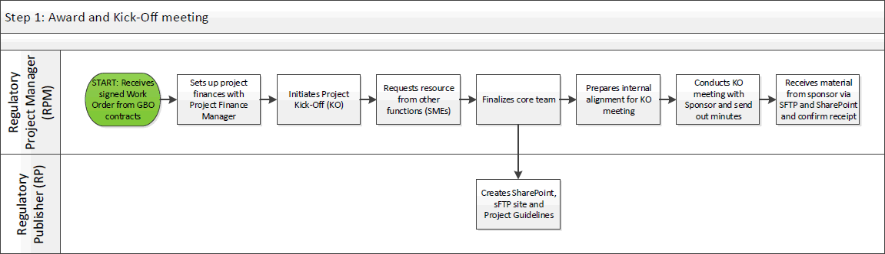

Appendix B: Step 2a: Gap Analysis Report
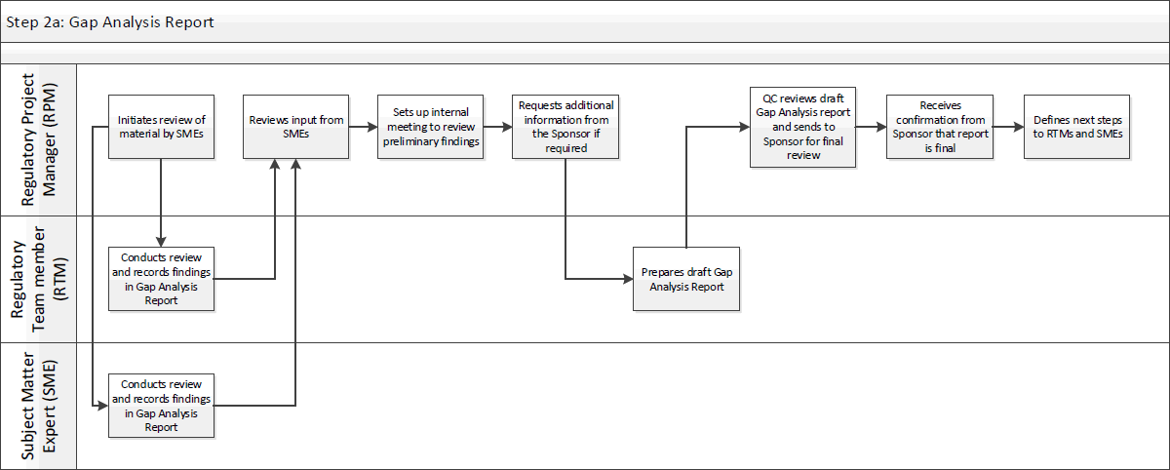

Appendix C: Step 2b: IND Readiness Assessment
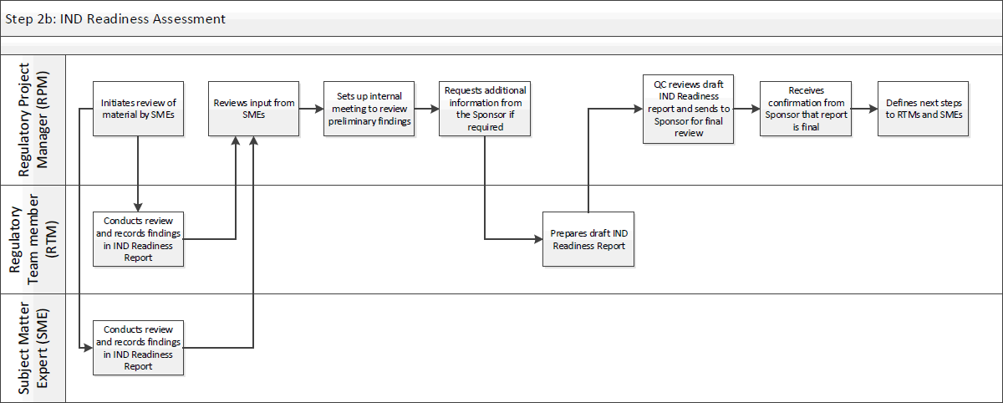

Appendix D: Step 3a: Pre- IND Meeting Request
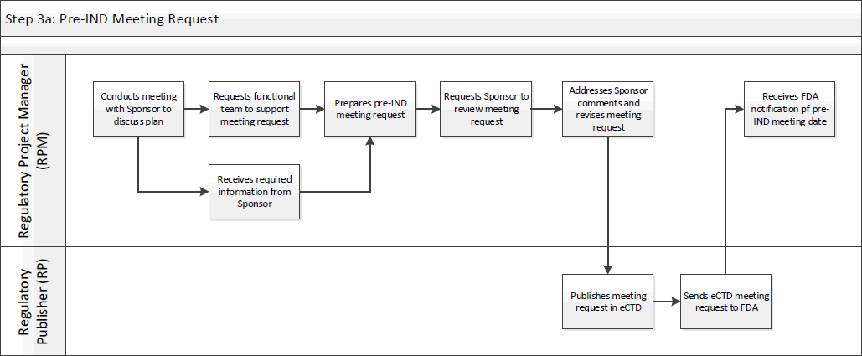

Appendix E: Step 3b: Preparation and Submissions of Meeting Information Package (MIP) / Briefing document
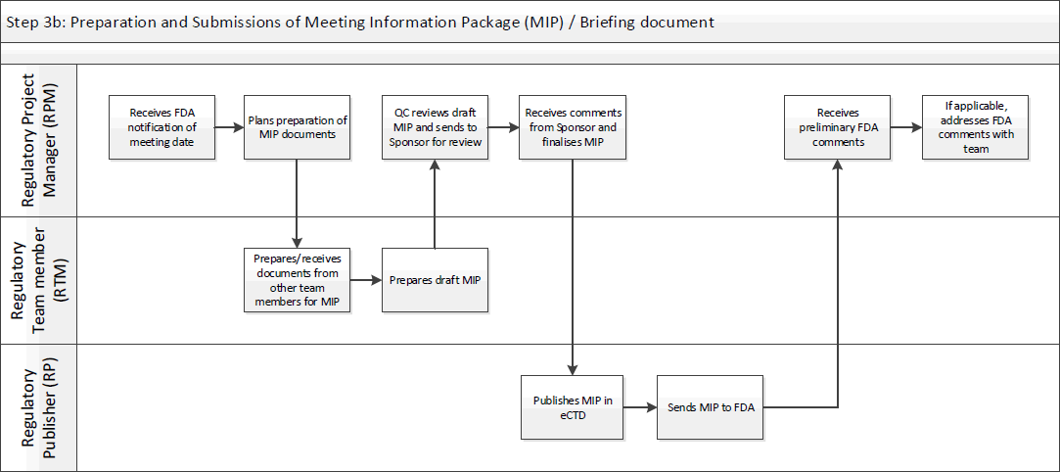

Appendix F: Step 3c: Pre-IND Meeting Rehearsal and meeting
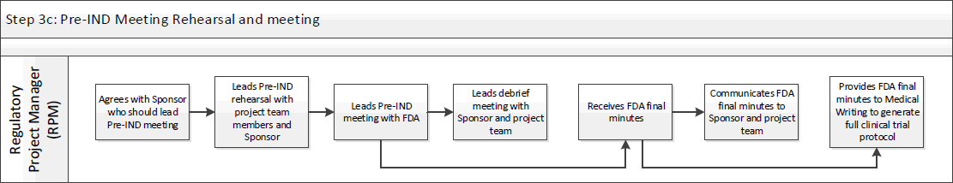

Appendix G: Step 4: IND Submission
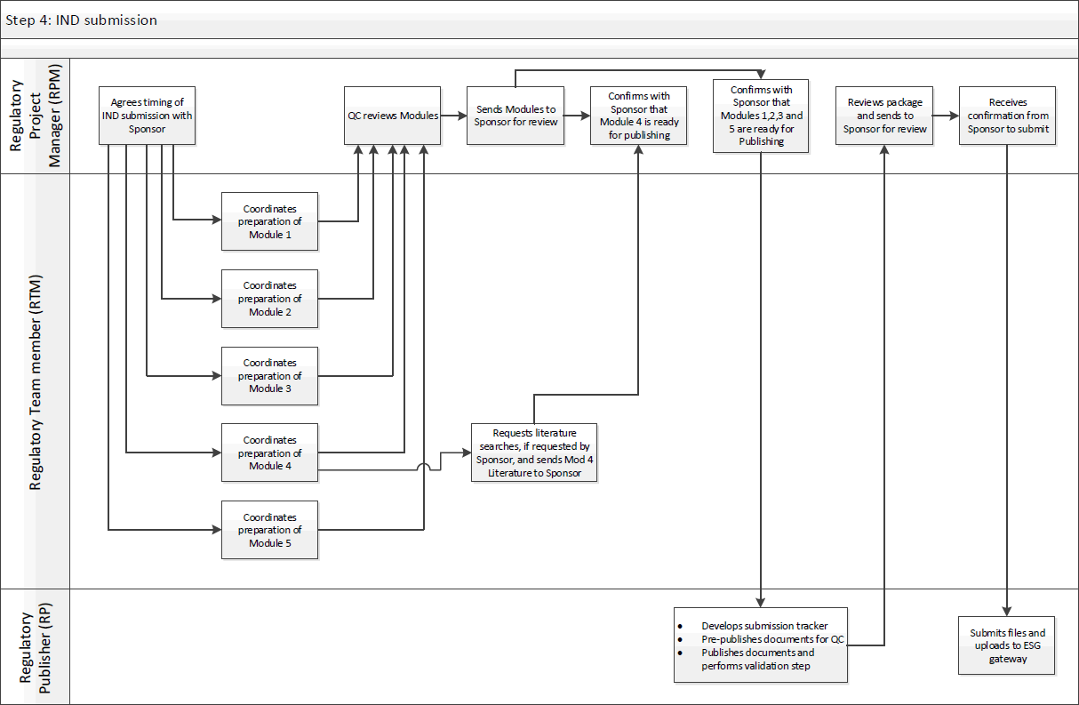

Standard Operating Procedure Approval Signature(s)
This is a representation of an electronic record that was signed electronically in Content Server.
This page is the manifestation of the electronic signature(s) used in compliance with the organization’s electronic signature policies and procedures
Refer to Signatories CV for Business Title.

UserName: Kemp, Jaco (q608126) Title:
Date: Friday, 01 April 2022, 11:10 AM Eastern Daylight Time Meaning: Signing this Document Indicates My Approval
================================================

UserName: Glizer, Veronica (q735279) Title:
Date: Friday, 01 April 2022, 02:38 PM Eastern Daylight Time Meaning: Signing this Document Indicates My Approval
================================================

UserName: Corley, Helen (q730385) Title:
Date: Monday, 04 April 2022, 04:26 AM Eastern Daylight Time Meaning: Signing this Document Indicates My Approval
================================================

UserName: Lewicky, Tamara (q730348) Title:
Date: Monday, 04 April 2022, 10:26 AM Eastern Daylight Time Meaning: Signing this Document Indicates My Approval
================================================

UserName: Tyagi, Ankit (q848582) Title:
Date: Tuesday, 05 April 2022, 07:12 AM Eastern Daylight Time Meaning: Signing this Document Indicates My Approval
================================================

UNCONTROLLED COPY CS_WI_RA0297 Revision 1 - EFFECTIVE on 01-May-2022

